Flight Management application
Scenarios Version 0
->Start code using TDD
Cases
- Add Passenger
- Add passenger only once.
- Aprove the request for economy flight but if not, economy flight approve only if passenger is VIP otherwise reject the request.
- Approve the request if only passenger is VIP otherwise reject the request.

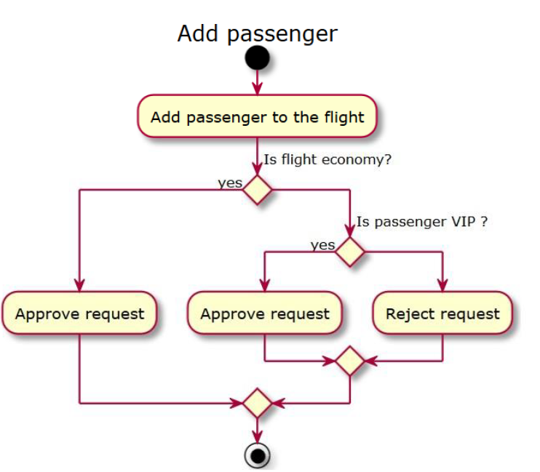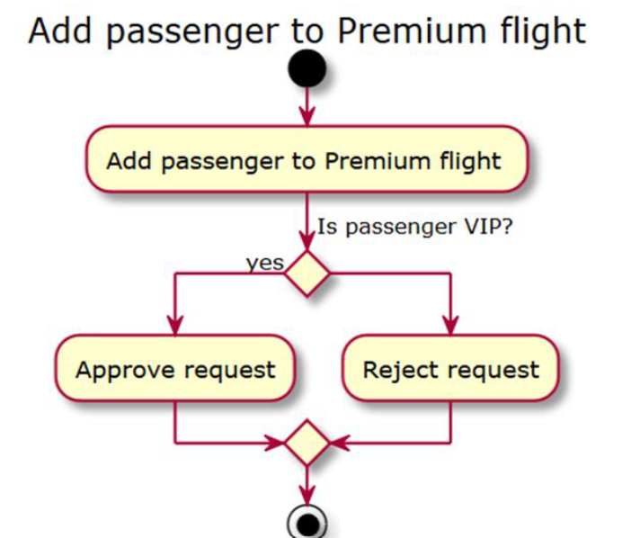
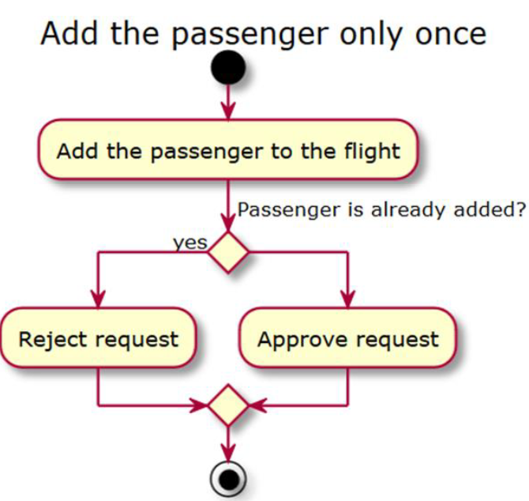
- Remove Passenger- Remove passengers from the flight.
VIP passengers
- Reject the request for VIP and approve the request for non-VIP.
- Remove passenger for Premium.
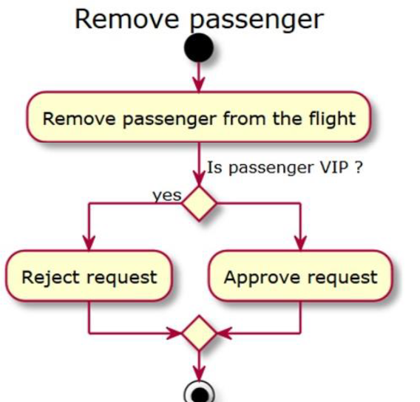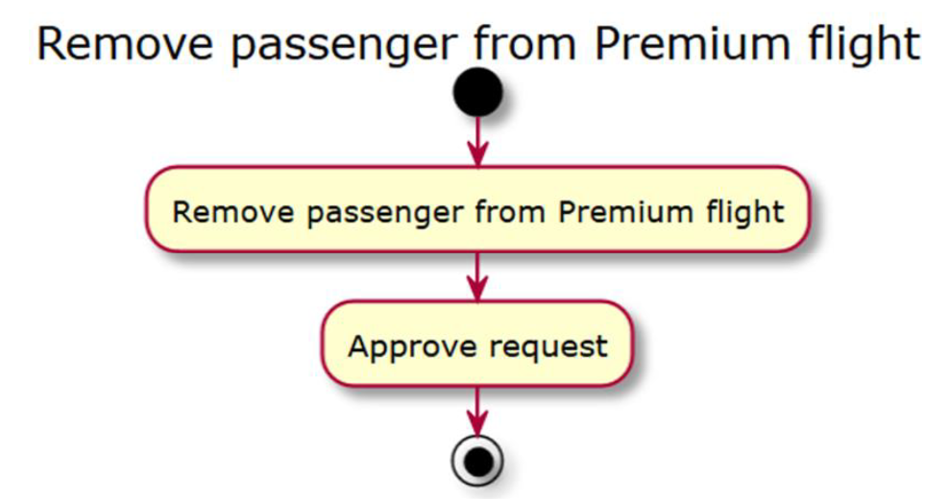
Conclusion-
a) Nouns Flight (Flight Type, Set<Passengers> passengers) and Passenger (VIP or not?)
b) Flight has methods boolean addPassenger(Passenger p), boolean removePassenger(), getPassengers:List<Passenger>

Scenarios Version 1
Improve it (replace conditional with polymorphism) and improve the test
- It's better polymorphism instead of using conditional. Which means remove Flight Type attribute and have different child classes, EconomyFlight, BusinessFlight, PremiumFlight
- by making flight abstract we can abstract methods
- boolean addPassenger(Passenger passenger);
- boolean removePassenger(Passenger passenger);

